3A. Write and execute the create view command to create the Order_Total view

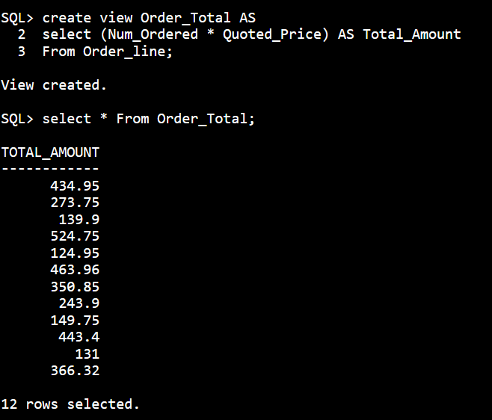

3B. Write and execute the command to retrieve the order number and order total for only those orders totaling more than $500.

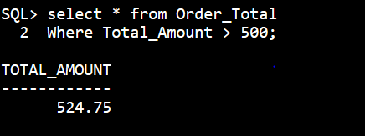

3C. Write and execute the query that the DBMS actually executes.

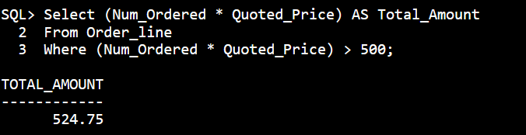

4A. User Ashton must be able to retrieve data from the ITEM table



4B. Users Kelly and Morgan must be able to add new orders and order lines.



4C. User James must be able to change the price for all items



